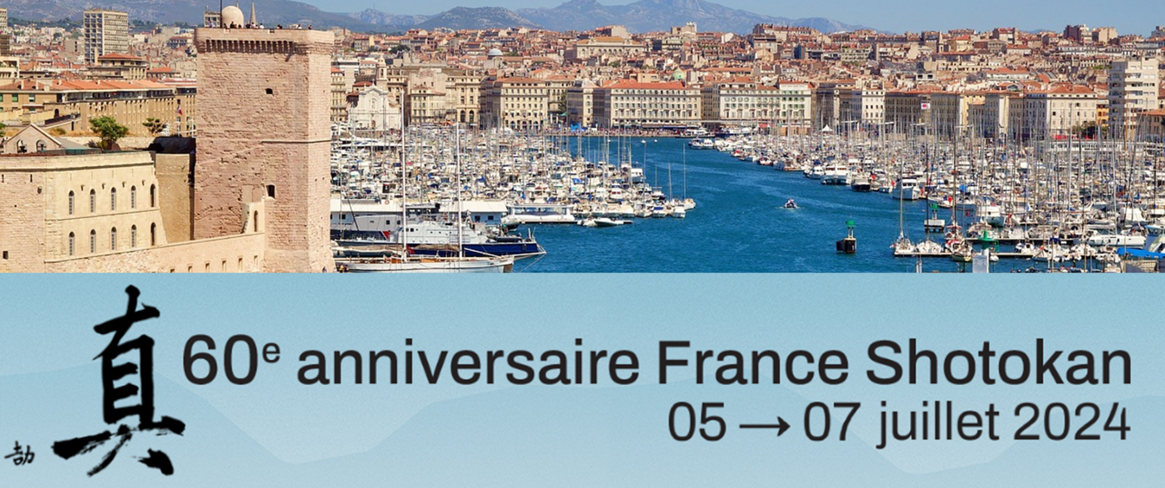
Program FSK 2024 - 60th anniversary:

Friday July 05, 2024:
03:00 pm: Welcome and registration of participants @ Dojo of Port Saint Louis (PSL)
6:30 p.m.: Welcome speech and Presentation of the festivities
7:00 p.m.: Cocktail dîner on site
8:00 p.m. - 10:00 p.m.: Black belt group lesson @ Dojo de PSL
9:00 p.m. and 10:30 p.m. Departure Shuttles to Arles Hotels

Saturday 06 July 2024:
09:30: Departure from Arles hotel shuttles to Dojo PSL
10:00 - 12:00: Group training for all - outdoors
12:30 - 13:30: Lunch
2:00 p.m. - 5:30 p.m.: International Tournament and Presentations
05:30 PM: Departure Shuttles to Hotels
07:00 PM Departure Shuttles to Reception
7:30 pm Festive Reception @ Beaux de Provence
11:00 p.m. and 12:00 a.m. Departure Shuttles to Arles Hotels

Sunday July 07, 2024:
09:00 Departure from Arles hotel shuttles to Dojo PSL
09:30 - 12:00: Collective training for all - outdoors
12:30 - 13:30: Lunch
02 PM- 04 PM: Godan test and Presentations
04 :30 PM Departure Shuttles from PSL to Arles Hotels
06 PM Departure Shuttles from Arles hotels to Marseille
6:30 p.m.: Gala Evening – Palais du Pharo @ Marseille
00:00 and 01: 00 AM Departure Shuttles to Hotel

End of the event.

